Flight Management using webflux and MongoDB(Screenshots)
- Post Request (add flight through inventory)
http://localhost:8080/api/v1.0/flight/airline/inventory/add
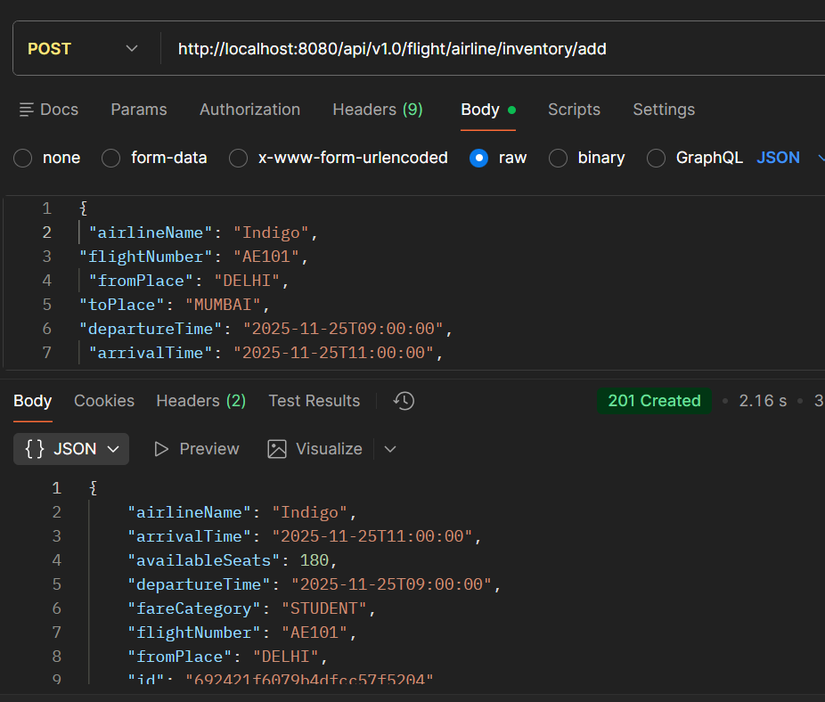

- Post request (to search for flights)
http://localhost:8080/api/v1.0/flight/search
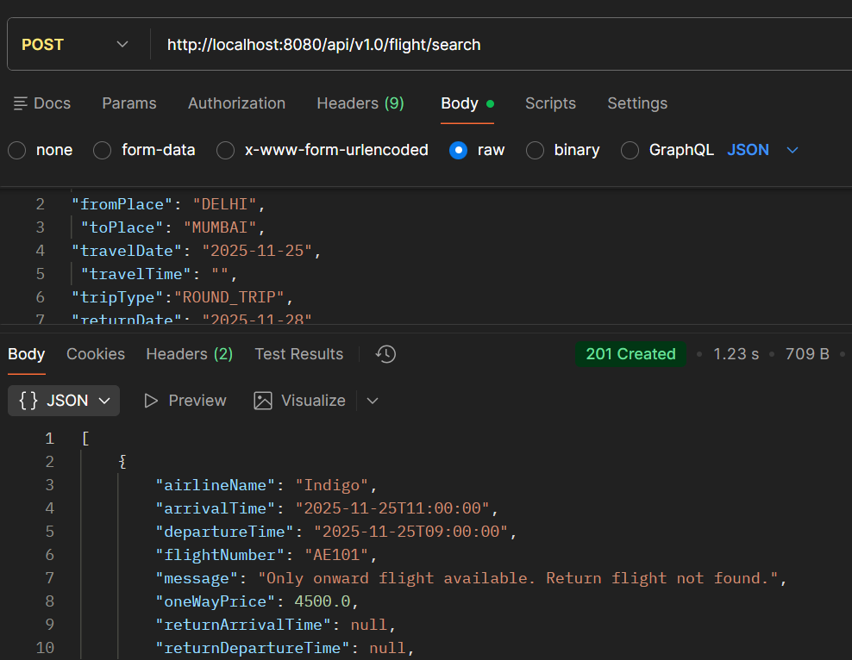

- POST request (make bookings)
http://localhost:8080/api/v1.0/flight/booking/692333797aa12acb5c314279

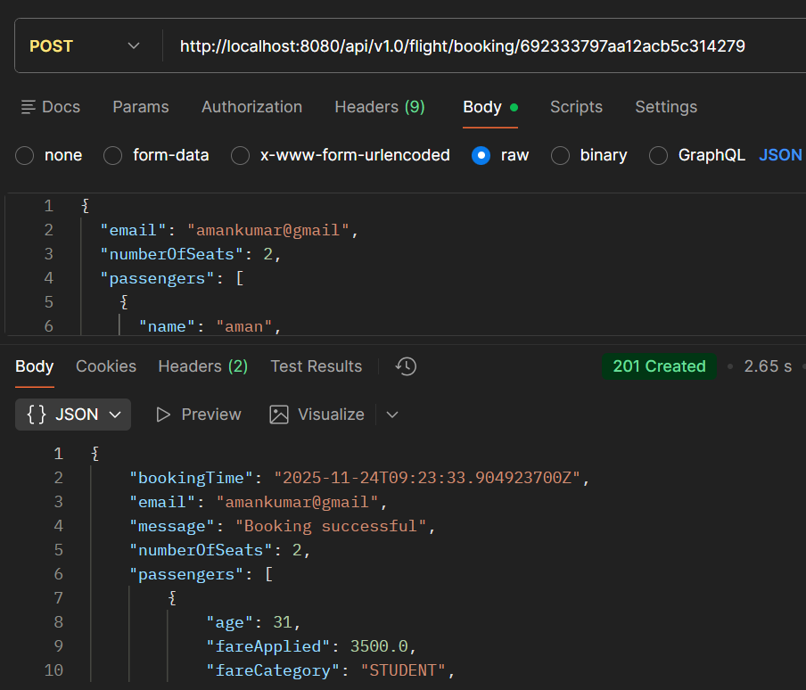
- GET request(ticket by PNR )
http://localhost:8080/api/v1.0/flight/ticket/L7V0HA
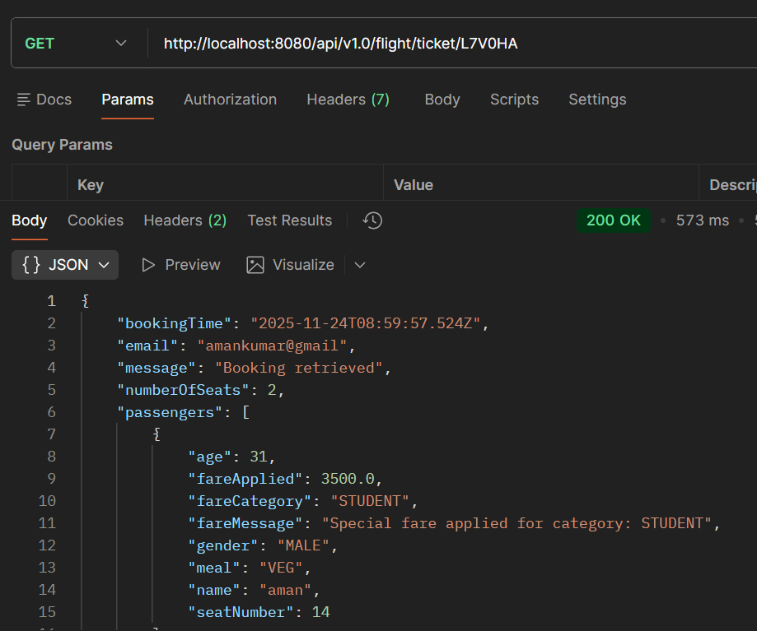
- GET request(see history by email)
http://localhost:8080/api/v1.0/flight/booking/history/amankumar@gmail
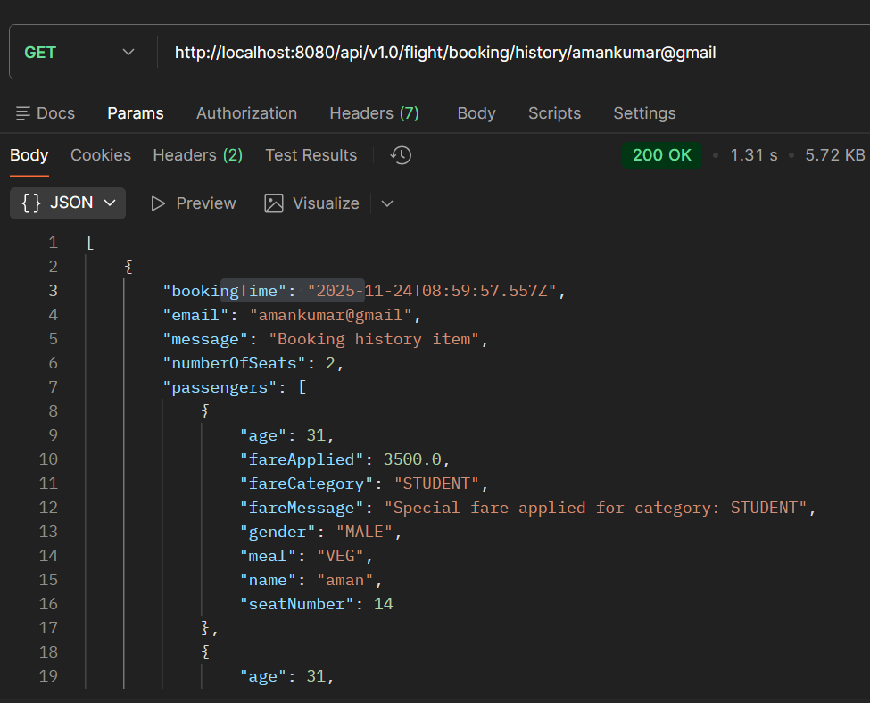
- DELETE request (delete the bookings through pnr )

http://localhost:8080/api/v1.0/flight/booking/cancel/TLXUMG

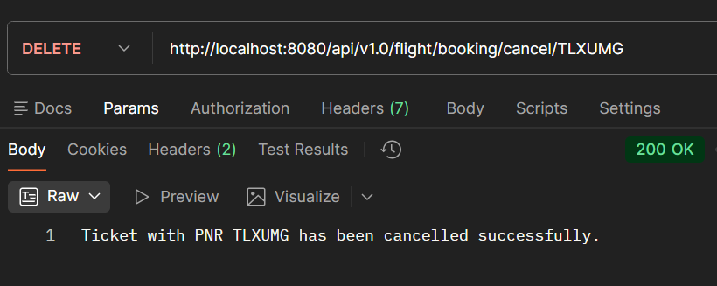

Jacoco report (code coverage )

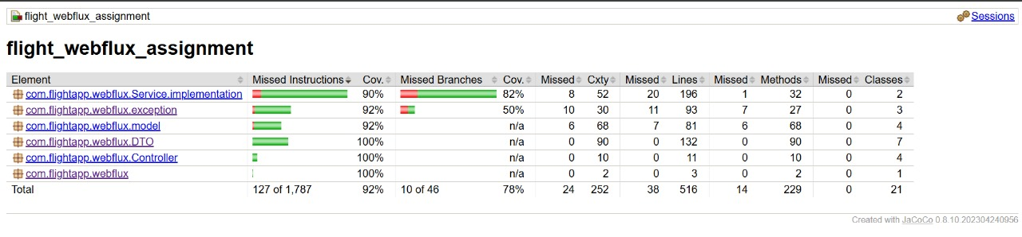

SonarQube attachment (before)

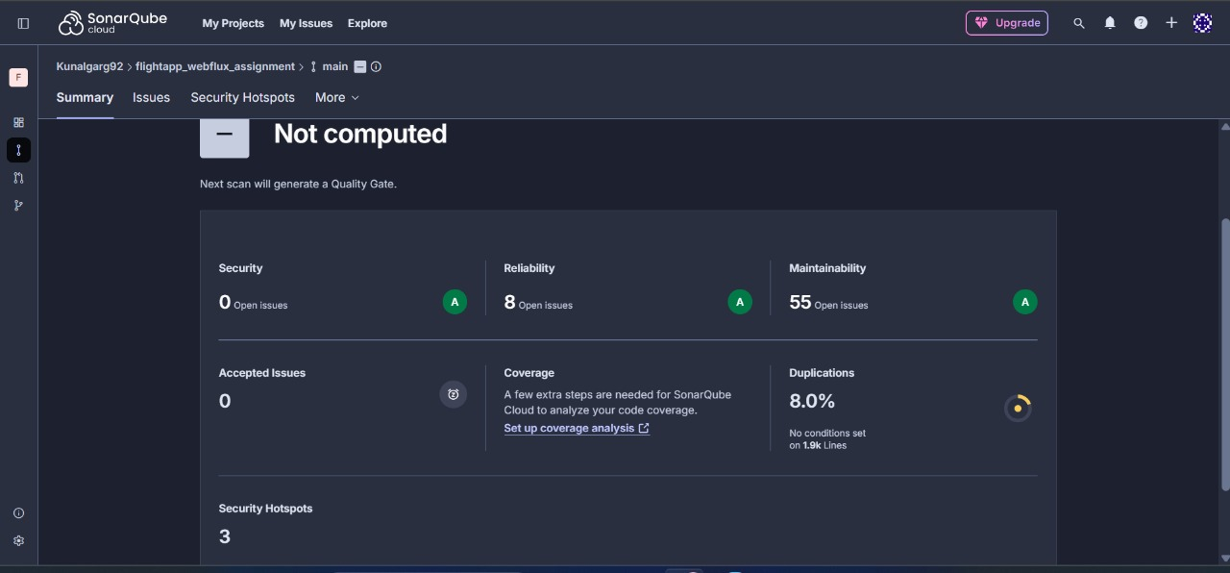
After running in cmd using { sonartoken}
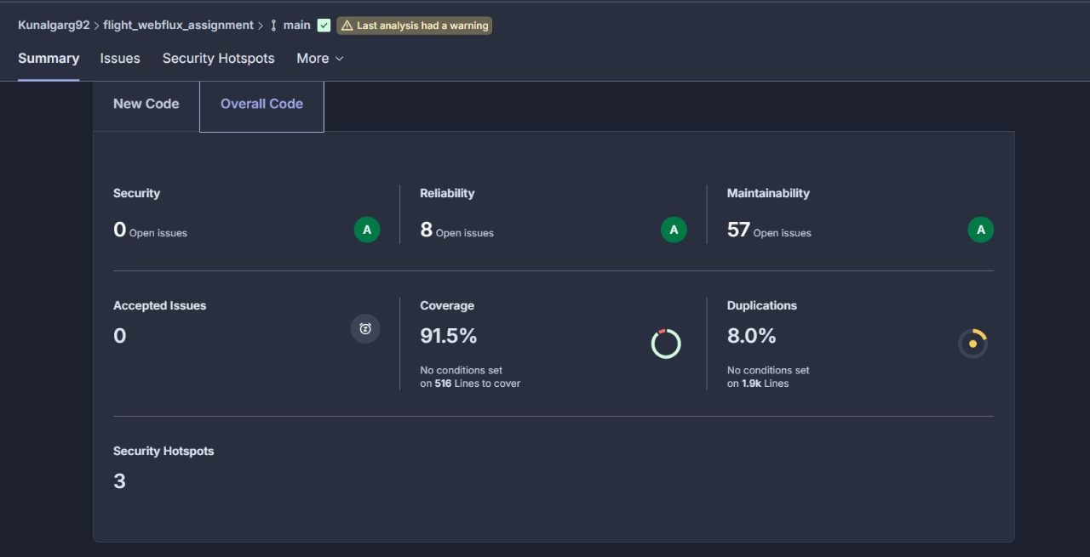

After (removed all duplications using Lombok and code coverage)

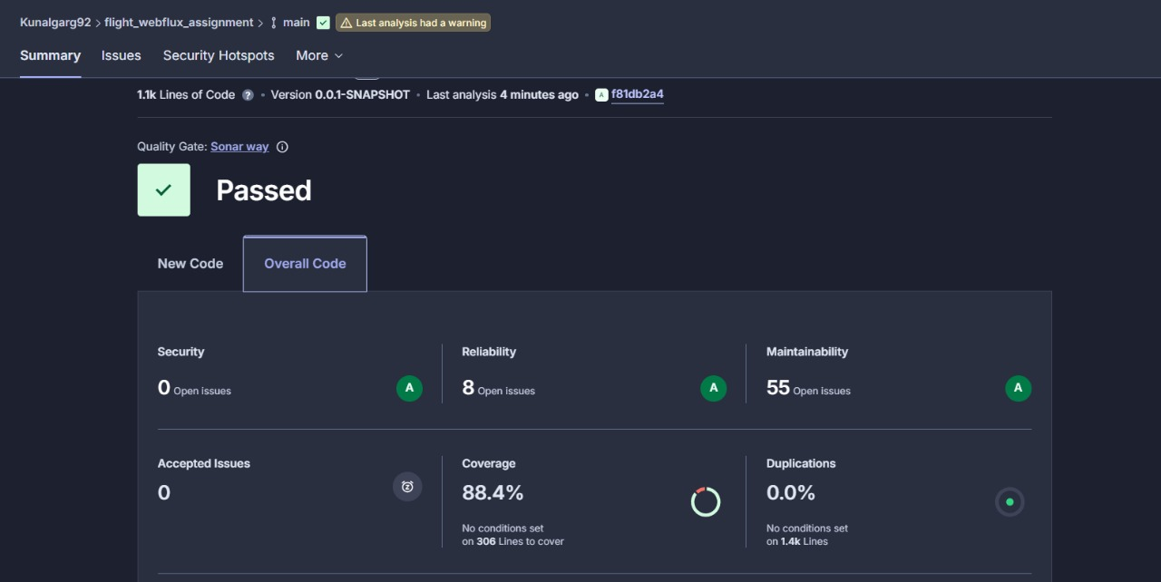

Jmeter Testing (for 20,50,100)

1)for 20 :

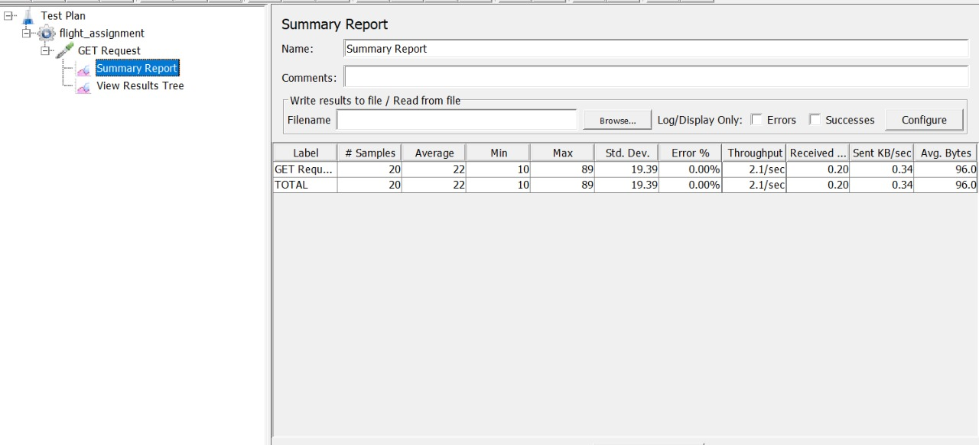

2) for 50 :

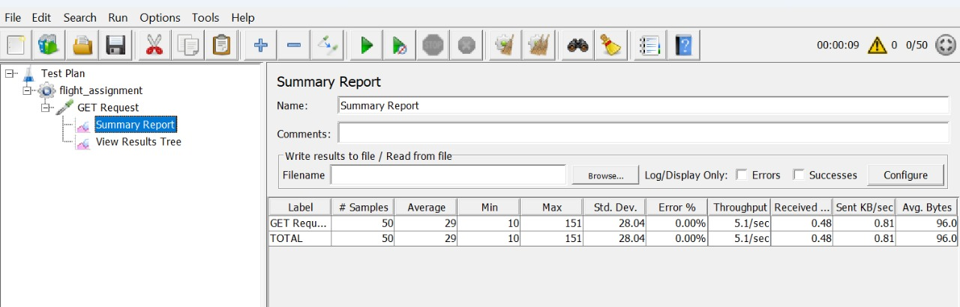

3) For 100:

